Student Responsibilities

- Students must have employment to be in the cooperative education and work experience. They must work at least 15 hours per week Monday through Friday.

- The student is expected to remain with the original job placement throughout the school term, and will not be granted permission to change without proper justification. He/she will not terminate employment with the training station without prior written consent of the teacher-coordinator.

- The student is expected to conform to employer rules and regulations. Professional dress, conduct, grooming, attendance, punctuality, and adherence to the work schedule are expected.

- The student is not allowed to work on days absent from school without prior approval of the teacher.

- The student must notify the employer and school each day he/she is unable to work, according to company policy.

- School will be the first priority! If a student is told by a teacher or administrator to remain after school, he/she must do so.

- The student is responsible for providing his/her own transportation to and from the training station.

- The student is expected to maintain accurate and up-to-date wage and hour records and complete connecting activities by established deadlines. Failure to submit records and assignments to the teacher as requested will result in failure and removal from the cooperative education program.

Parent/Guardian Responsibilities

- To encourage the student to effectively carry out his/her duties and responsibilities as outlined in this agreement.

- To assume responsibility for the conduct, transportation, and necessary insurance of the student while in the training program; including the time in class, on the job, and en route to school, the job, and home.

- To work cooperatively with the teacher and the student in solving problems relating to school and work.

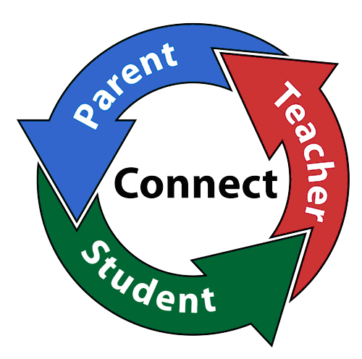
- Be aware that students are not allowed to report to the training station on days they are absent from school unless they receive permission from the teacher-coordinator.

Employer Responsibilities

- To assist in training plan development on a grading-period basis.

- To place the student in a training position for providing educational and employment experiences and tasks of instructional value.

- To place the student on the work schedule for at least 15 hours a week (Monday through Friday.)

- To notify the teacher if difficulties arise, changes are necessary, a lay-off, or termination of employment seems likely to occur.



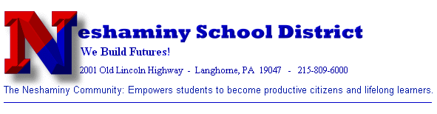

Neshaminy
High
School
School to Work Transition Program
(SWTP)



Dr. Robert McGee, Principal

Mr. William Ritchey, 12th Grade Principal

Joanne B. Lance, Coordinator
School-to-Work Transition Program

2001 Old Lincoln Highway
Langhorne, PA 19047

Phone: 215-809-6678
Fax: 215-809-6121
E-mail: jlance@neshaminy.k12.pa.us

School-to-Work
Transitional Program

The School-to-Work Transitional Program (SWTP) is designed to provide an opportunity for senior students to work in an approved job station, supervised both by the student’s employer and the SWTP Coordinator. The SWTP student will earn two course credits for successful on-the-job experience, and a third course credit for successful participation in a daily seminar class.

The daily seminar class will consist of job-related instruction designed to assist students in the various aspects of the world of work, as well as provide an opportunity for career exploration and individual career planning.

In addition to the seminar class, students will elect English, Social Studies and a Physical Education course. Students may schedule additional subjects if desired or if necessitated by graduation requirements. All SWTP credits count for graduation.

SWTP students will have their schedule arranged to complete all course selections in the morning and be excused early to report to the job. Transportation to work is the responsibility of the student. Students are required to have working papers before entering the SWTP Program.

Capstone Activity Packets

The Capstone Activity Packets (CAPS) were designed to be used by School-to-Work students during their in-school class period. These modules were first developed in 1989 by Cooperative Education teachers in Pennsylvania and follow the 37 key competencies required of Cooperative Education programs by the Commonwealth of Pennsylvania. The modules were revised in 2003 with input from Cooperative Education teachers in Pennsylvania.

The student activities have been enhanced so the modules could be aligned with the Pennsylvania Academic Standards of Career Education and Work; the Reading, Writing, Listening, Speaking standards; and the Department of Labor’s Employability Standards (SCANS).



www.pde.state.pa.us/career_ed/

Areas Studied

- Orientation: identify co-op programs goals, policies and procedures, describe work ethics, and discuss the transition from the classroom to the actual job situation.

- Human Relations: evaluate personality traits, list characteristics of a responsible employee, describe positive working relationships with others on the job, and demonstrate ways to resolve conflict.

- Health and Safety: identify appropriate occupational safety practices and procedures; describe the role of government agencies in providing for a safe workplace.

- Employment Retention: show interest, enthusiasm, initiative, and assertiveness on the job.

- Communications: distinguish positive and negative feedback.

- Consumer Skills: understand and prepare a sample budget, fringe benefits provided by the employer, know how to open a checking account, balance a checkbook, apply for a loan and demonstrate the ability to file Federal, state, and local tax forms.

- Legal Awareness: obtaining an employment certificate.

- Future Planning: resumes, short-term and long-term goals.

